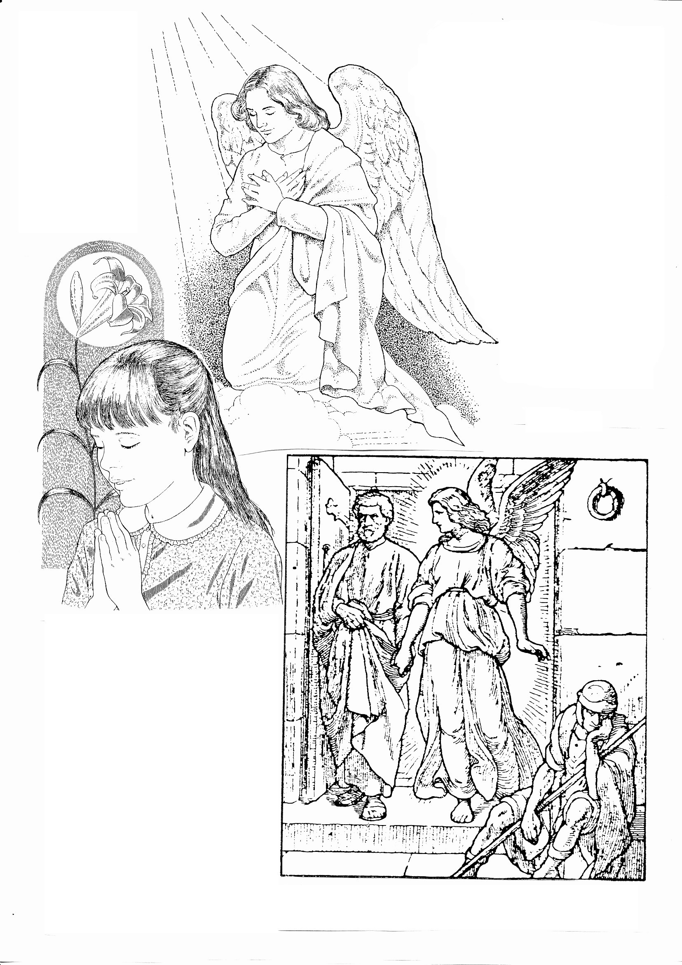
6
A good girl
and her
Guardian
Angel
praying
together

Angels are spirits. They are
intelligent and have free will
but they have no bodies.
However, so that we can
picture them we show
them with winged bodies.
We all have one
guardian angel each
to help us be good
and to protect us.

Prayer to my Guardian Angel

Angel of God,
my guardian dear,
to whom His love
commits me here,
ever this day be at my side
to light and guard,
to rule and guide.
God sometimes sends out an angel to do a particular job for him.
This happened during the life of St Peter the leader of the apostles.
When he was locked up in prison God sent an angel to set him free.

